Top file records in file –

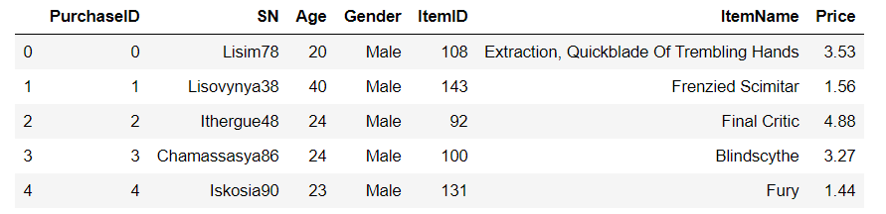

Bottom five records in file –

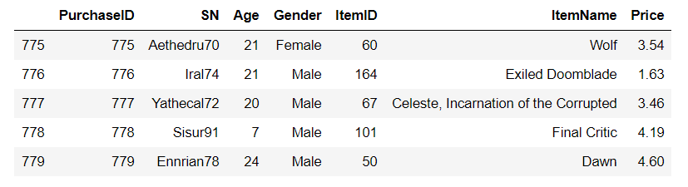

Player Count –

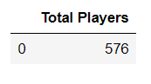

Total Unique items, Avg Price, Number of Purchases and Total Revenue –

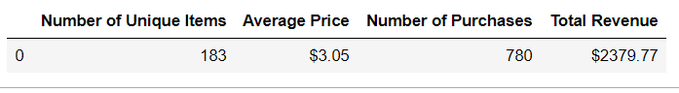

Player count and percentage by Gender –

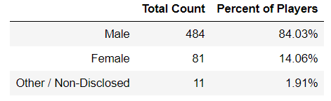

By Gender – Purchase Count, Average Purchase Price, Total Purchase Value, Avg Total Purchase Per Person

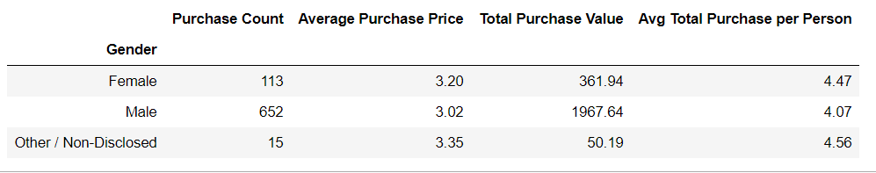

Count and Percentage by age range –

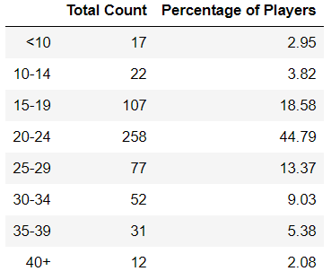

By Age Range – Purchase Count, Average Purchase Price, Total Purchase Value, Avg Total Purchase Per Person

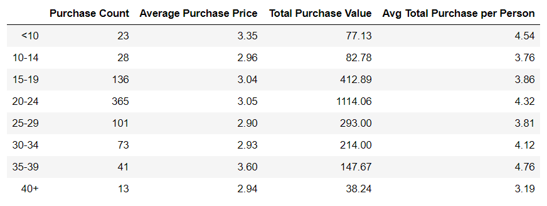

Top Spenders –

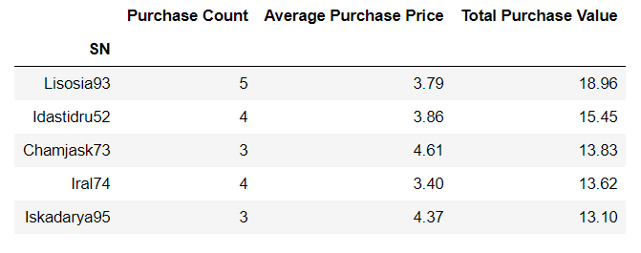

Most Popular Items –

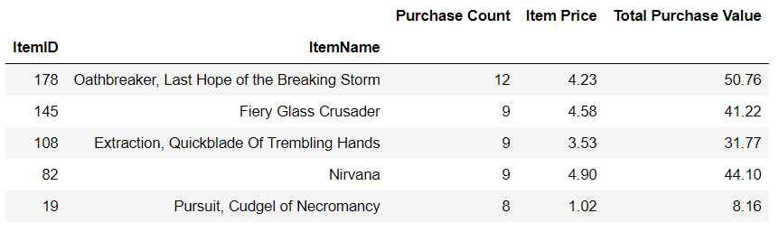

Most Profitable Items –

